Description on how to download FTSE index symbols and industry sector symbols from London Stock Exchange:

Several FTSE index lists are available at the http://www.londonstockexchange.com website, such as FTSE 350, AIM UK 100, SmallCap, etc. For example, FTSE 350 index symbols can be obtained from

http://www.londonstockexchange.com/exchange/prices-and-markets/stocks/indices/constituents-indices.html?index=NMX&industrySector=&page=1

However, there are 18 pages of component symbols for FTSE 350 index. HSQuote Plus with the “MyWebServer” feature can automate the collection of all these component symbols in one ticker list, for later data download.

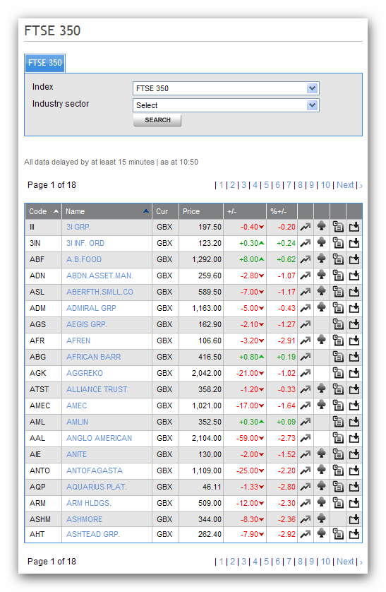

Similarly, each index can have different industry sectors. Some users may want to download data or group data in specific sectors. For example, the “Support Services” sector for FTSE 350 is available at

http://www.londonstockexchange.com/exchange/prices-and-markets/stocks/indices/constituents-indices.html?index=NMX&industrySector=2790&page=1

Again, ticker lists for specific sectors of a specific index can be automatically downloaded on HSQuote Plus.

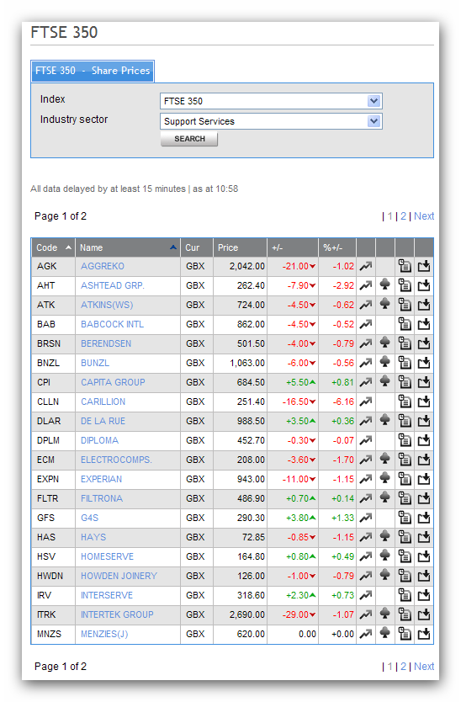

Set-up for Index Component Ticker Lists:

- Copy the following lines and append to your existing “mywebserver.txt”, or simply substitute it with the attached “mywebserver.txt”.

FTSE-Index-Symbols,http://www.londonstockexchange.com/exchange/prices-and-markets/stocks/indices/constituents-indices.html?index=SSSS&industrySector=&page=NNNN,DL1,londonstockexchange-symbol_DL1.fmt

- Copy the “londonstockexchange-symbol_DL1.fmt” file to the “fmt” subfolder in the Data File Location indicated on the Preference Setting screen.
- Copy the attached “config_FTSE-Symbols.cfg” and “alias_FTSE.csv” files to the HSQuote Plus program installation folder.
- Run HSQuote Plus and set up “FTSE-Index-Symbols.tic” as shown. Note that only 3 tickers are shown. Users can add more. The ticker names here will be used as the .tic file names. For example, “FTSE100” will create the “FTSE100.tic” with all the component stock symbols automatically later.

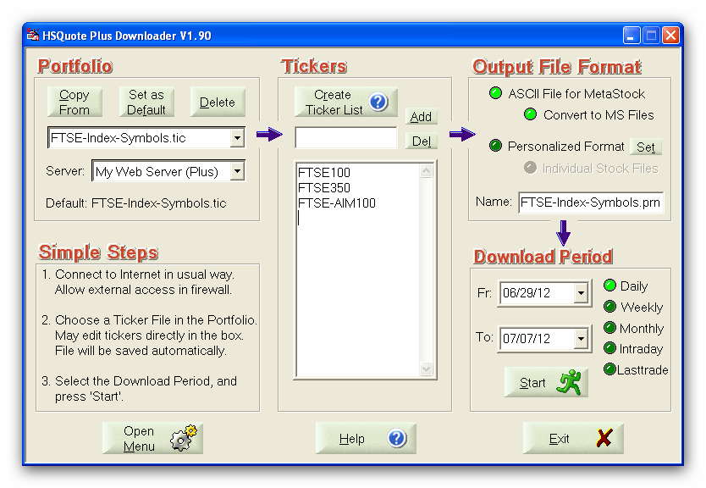

- If more tickers are added, users will need to add the corresponding alias names used on the http://www.londonstockexchange.com website to the “alias_FTSE.csv” file.

Download and Collect Index Component Ticker Lists:

Just bring up the “FTSE-Index-Symbols.tic” portfolio, select Daily or Lasttrade download, and click on the “Start” button. That’s it.

After download is completed, go to the “FTSE-Index-Symbols” subfolder in the Data File Location, open the “Text-Files” subfolder, and all the .tic lists are in here. You can manually copy all these .tic files to the Data File Location (together with all the other normal .tic files). You may also do this step with the “PostDownloadProcessing” feature.

Set-up for Sector Component Ticker Lists:

- Copy the following lines and append to your existing “mywebserver.txt”, or simply substitute it with the attached “mywebserver.txt”.

FTSE-Sector_XXXX,http://www.londonstockexchange.com/exchange/prices-and-markets/stocks/indices/constituents-indices.html?index=XXXX&industrySector=SSSS&page=NNNN,DL1,londonstockexchange-symbol_DL1.fmt

- Copy the “londonstockexchange-symbol_DL1.fmt” file to the “fmt” subfolder in the Data File Location indicated on the Preference Setting screen. This has been down for the Index Ticker Lists download above.
- Copy the attached “config_FTSE-Symbols.cfg” and “alias_FTSE.csv” files to the HSQuote Plus program installation folder. This has been down for the Index Ticker Lists download above.
- Run HSQuote Plus. For each Index, say FTSE 350, set up “FTSE-Sector_NMX.tic” as shown. Here “NMX” is the name used for FTSE 350 on the http://www.londonstockexchange.com website. Note that only 2 tickers for 2 sectors are shown, but users can add more. The ticker names here will be used as the .tic file names. For example, “Support-Services” will automatically create the “Support-Services.tic” with all the component stock symbols in the Support Services sector of the FTSE 350 index.

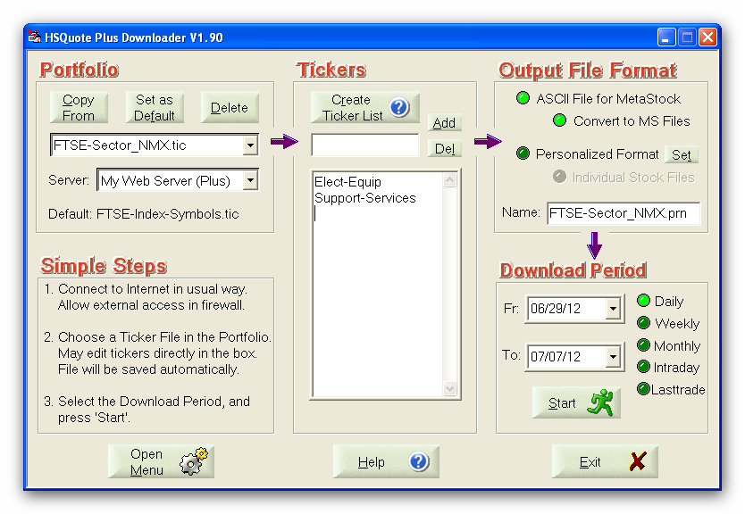

- If more tickers are added, users will need to add the corresponding alias names used on the http://www.londonstockexchange.com website to the “alias_FTSE.csv” file.

Download and Collect Sector Component Ticker Lists:

Just bring up the “FTSE-Sector_NMX.tic” or other sector portfolio, select Daily or Lasttrade download, and click on the “Start” button. That’s it.

After download is completed, go to the “FTSE-Sector_NMX” subfolder in the Data File Location, open the “Text-Files” subfolder, and all the .tic lists are in here. You can manually copy all these .tic files to the Data File Location (together with all the other normal .tic files). You may also do this step with the “PostDownloadProcessing” feature.

